**ASSIGNMENT 2 FRONT SHEET**

|  |  |  |  |
| --- | --- | --- | --- |
| **Qualification** | **BTEC Level 5 HND Diploma in Computing** | | |
| **Unit number and title** | 10: Website Design & Development | | |
| **Submission date** | 27/08/2022 | **Date Received 1st submission** |  |
| **Re-submission Date** |  | **Date Received 2nd submission** |  |
| **Student Name** | Bùi Hương Linh | **Student ID** | GBH200662 |
| **Class** | GCH1006 | **Assessor name** | Lai Manh Dung |
| **Student declaration**  I certify that the assignment submission is entirely my own work and I fully understand the consequences of plagiarism. I understand that making a false declaration is a form of malpractice. | | | |
|  |  | **Student’s signature** | Linh |

**Grading grid**

|  |  |  |  |  |  |  |
| --- | --- | --- | --- | --- | --- | --- |
| P5 | P6 | P7 | M4 | M5 | D2 | D3 |
|  |  |  |  |  |  |  |

|  |  |  |
| --- | --- | --- |
| **❒ Summative Feedback: ❒ Resubmission Feedback:** | | |
| **Grade:** | **Assessor Signature:** | **Date:** |
| **Signature & Date:** | | |

Table of Contents

Introduction 6

Chapter 1 – Design Plan 6

1. User’s requirements 6

2. Review accessibility standards and guidelines 6

3. Use cases diagram 7

4. Wireframes 8

4.1. Home page 8

4.2. Register 9

4.3. Log in 10

4.4. Product detail 11

4.5. Admin 12

5. Sitemap 13

Chapter 2 – Implementation 14

1. Home page 14

HTML header, logo 15

CSS header, logo 15

HTML search 15

PHP search 16

CSS search 16

HTML login, register 16

CSS login, register 17

HTML sidebar 18

CSS sidebar 18

HTML and PHP ads 19

CSS ads 19

PHP and HTML maincontent, all product 20

CSS maincontent and all product 20

HTML footer 21

CSS footer 21

2. Product detail 22

PHP and HTML product detail 22

CSS product detail 23

3. Register 24

HTML and PHP register 24

CSS register 25

4. Login 25

HTML and PHP login 25

CSS Login 26

5. Admin page 27

HTML header, logo, search, logout 27

CSS header, logo, search, logout 28

HTML and PHP maincontent 29

CSS maincontent 30

HTML and PHP add new product, update product 31

CSS add new product and update product 33

HTML and PHP delete product 33

Function session_start 33

My SQL database 34

Chapter 3 – Testing 35

Conclution 37

Evaluation 37

References 37

Figure 1: Use case diagram 8

Figure 2: Home page web 9

Figure 3: Register 10

Figure 4: Login 11

Figure 5: Product detail 12

Figure 6: Admin 13

Figure 7: Site map 14

Figure 8: Home page 14

Figure 9: HTML header, logo 15

Figure 10: CSS header, logo 15

Figure 11: HTML search 15

Figure 12: PHP search 16

Figure 13: CSS search 16

Figure 14: HTML login and register 16

Figure 15: CSS login and register 17

Figure 16: HTML sidebar 18

Figure 17: CSS sidebar 18

Figure 18: HTML and PHP ads 19

Figure 19: CSS ads 19

Figure 20: PHP and HTML maincontent, all product 20

Figure 21: CSS maincontent and all product 20

Figure 22: HTML footer 21

Figure 23: CSS footer 21

Figure 24: Product detail 22

Figure 25: PHP and HTML product detail 22

Figure 26: CSS product detail 23

Figure 27: HTML and PHP register 24

Figure 28: CSS register 25

Figure 29: HTML and PHP login 26

Figure 30: CSS Login 27

Figure 31: Admin page 27

Figure 32: HTML header, logo, search, logout 27

Figure 33: CSS header, logo, search, logout 28

Figure 34: HTML and PHP maincontent 29

Figure 35: CSS maincontent 30

Figure 36: HTML and PHP add new product, update product 32

Figure 37: CSS add new product and update product 33

Figure 38: HTML and PHP delete product 33

Figure 39: Function session_start 33

Figure 40: My SQL database 34

Table 1: Test case 36

# Introduction

Based on what the author has learnt from professors and other sources, the author will discuss website design concepts in her study. The building of an actual website is subsequently entrusted to them by the author. User interface design, website design, and website functionality and performance testing were the author's three divisions of the project. This report will go into great detail on how the author created their website.

# Chapter 1 – Design Plan

1. User’s requirements

Levents (Including T-shirts, hoodies, jackets, ...)

Users (customers) will be able to:

* View all products of the shop.
* View the product list and the list of utensils for customers.
* View detailed product information.

Users (admins) will be able to:

* Add, delete and update all products.
* Must be logged in with the correct account to use the functions.

1. Review accessibility standards and guidelines

The success of every website depends heavily on its web design. Whether or not it was carefully made by the designer. Usability and utility, not graphic design, decide how well your custom-designed website performs. Because it is the face of your company to the outside world and where the bulk of potential customers will go before visiting your store, your website has been carefully created. The inevitable is the key. Any flaw could harm your company's reputation. It takes a diverse group of people with expertise in several fields to create a decent website. Their combined efforts must be considered when making a key choice. The following list of sound design guidelines will help you make your website more aesthetically pleasing, user-friendly, dependable, and interesting. (He, 2020)

* Perceivable:
* Text alternatives: Make text versions of any content available in any different formats that people may need, such as Braille, large print, voice-over, symbols, or plainer language.
* Make it simpler for consumers to see and hear content by being distinctive, such as by distinguishing the foreground from the background.
* Adaptive: Produce content that can be shown in a variety of ways without losing any of its structure or information.
* Provides time-based media (often video) alternatives, such as subtitles, explained audio, or alternate media.

(He, 2020)

* Operable:
* Make it simpler for users to use input methods other the keyboard to activate the functionality. Take the minimum size of the touch target as an example.
* Enough Time: Give users enough time to read and utilize the content. Examples of this include interrupts and timeouts, as well as moving, flashing, scrolling, or automatically updating information.
* Provide tools that help people navigate their way around, find content, and locate themselves. This area includes crucial user interface choices like information architecture, order of focus, and appropriate headings and labels.
* Seizures and Physical Reactions: Avoid making materials that could cause seizures or other physical reactions. Typically, this involves limiting flicker and motion animation to reasonable levels.
* Provides all of the keyboard's features when it is keyboard accessible. This is the ability to use the keyboard interface to switch the focus amongst all page elements.

(He, 2020)

* Understandable:
* Predictability: Make Web pages look and behave consistently. This includes predictable component interactions and consistent navigation.
* Assist users in avoiding and correcting errors through input assistance. This includes detecting input errors and providing appropriate, timely, and relevant instructions or suggestions.
* Readability: Make written content understandable and readable. This could be as simple as detecting and explaining idioms or acronyms, or it could be as complex as detecting and explaining idioms or acronyms.

(He, 2020)

* Robust:
* Compatibility: It is important to maximize compatibility with current and future user agents. This is primarily developer labor to ensure that the product is compatible with assistive technologies.

(He, 2020)

1. Use cases diagram

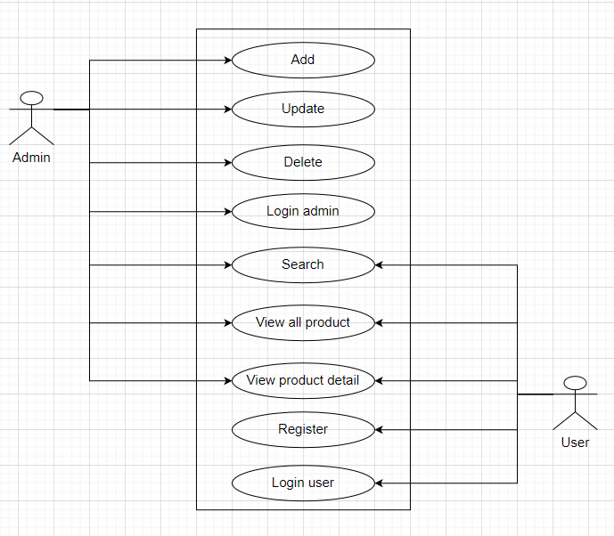

Figure 1: Use case diagram

1. Wireframes
   1. Home page

Figure 2: Home page web

* 1. Register

Figure 3: Register

* 1. Log in

Figure 4: Login

* 1. Product detail

Figure 5: Product detail

* 1. Admin

Figure 6: Admin

1. Sitemap

Figure 7: Site map

# Chapter 2 – Implementation

1. Home page

Figure 8: Home page

Users can search for products by searching or selecting the type of product they want on this page, which serves as both the home page and the shopping page.

### HTML header, logo

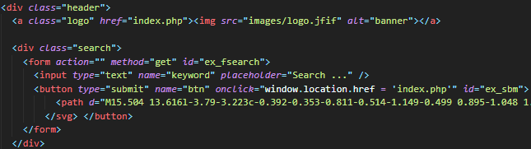

Figure 9: HTML header, logo

### CSS header, logo

Figure 10: CSS header, logo

When the user hovers over the logo icon, the browser takes them back to the home page.

### HTML search

Figure 11: HTML search

The browser will display the corresponding products when the user clicks on the search box for the product they want to find.

### PHP search

Figure 12: PHP search

### CSS search

Figure 13: CSS search

### HTML login, register

Figure 14: HTML login and register

The browser will display the corresponding window when the user clicks on the register or login button.

### CSS login, register

Figure 15: CSS login and register

### HTML sidebar

Figure 16: HTML sidebar

Displays a list of products from which users can select.

### CSS sidebar

Figure 17: CSS sidebar

### HTML and PHP ads

Figure 18: HTML and PHP ads

Randomly display images products.

### CSS ads

Figure 19: CSS ads

### PHP and HTML maincontent, all product

Figure 20: PHP and HTML maincontent, all product

Show all product and product detail.

### CSS maincontent and all product

Figure 21: CSS maincontent and all product

### HTML footer

Figure 22: HTML footer

Show how to contact the store.

### CSS footer

Figure 23: CSS footer

1. Product detail

Figure 24: Product detail

When users click on any product on the homepage, they will see product details like.

### PHP and HTML product detail

Figure 25: PHP and HTML product detail

Show product details.

### CSS product detail

Figure 26: CSS product detail

1. Register

HTML and PHP register

Figure 27: HTML and PHP register

The customer must create an account and the information is saved in the database.

### CSS register

Figure 28: CSS register

1. Login

HTML and PHP login

Figure 29: HTML and PHP login

When a user clicks the login, the browser displays the login panel, and if the user is logged in with an admin account, it takes the user to the admin page.

## CSS Login

Figure 30: CSS Login

1. Admin page

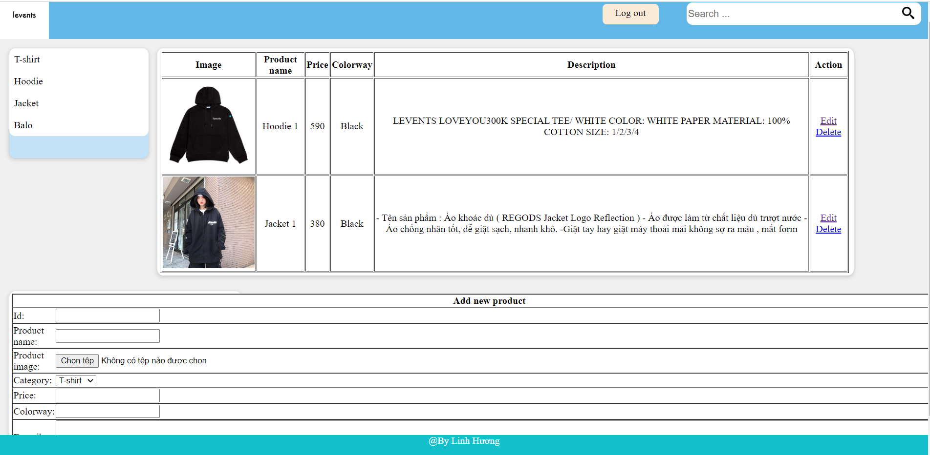

Figure 31: Admin page

Admin can add, edit, delete products when out of stock or have a new model.

### HTML header, logo, search, logout

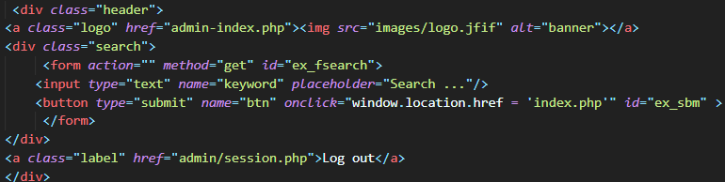

Figure 32: HTML header, logo, search, logout

When the user hovers over the logo icon, the browser takes them back to the home page.

The browser will display the corresponding products when the user clicks on the search box for the product they want to find.

When the user clicks the Logout button, the browser logs out of the account and returns to the website's homepage.

### CSS header, logo, search, logout

Figure 33: CSS header, logo, search, logout

### HTML and PHP maincontent

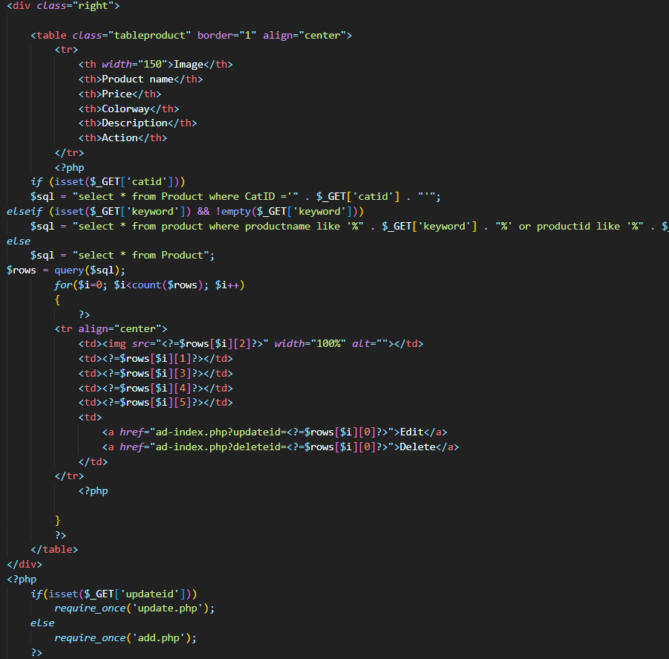

Figure 34: HTML and PHP maincontent

Display a list of products that are currently available for editing by users.

### CSS maincontent

Figure 35: CSS maincontent

### HTML and PHP add new product, update product

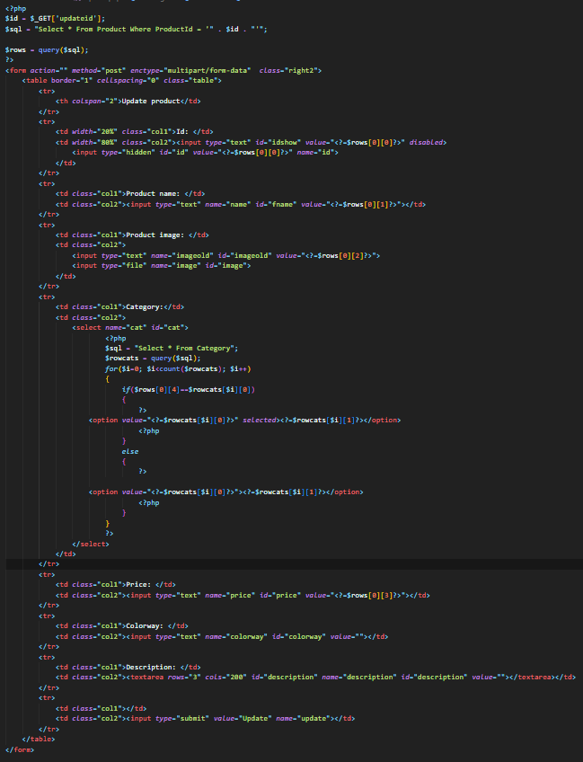

Figure 36: HTML and PHP add new product, update product

Used to add new product and update product.

### CSS add new product and update product

Figure 37: CSS add new product and update product

### HTML and PHP delete product

Figure 38: HTML and PHP delete product

To delete the product's, click "Delete" and that product will be deleted from the database.

### Function session_start

Figure 39: Function session_start

Used to log out the account and return the user to the website's homepage.

### My SQL database

Figure 40: My SQL database

# Chapter 3 – Testing

|  |  |  |  |  |  |  |
| --- | --- | --- | --- | --- | --- | --- |
| Testing case ID | Test case description | Test steps | Test data | Expected result | Actual result | Status |
| 1 | Choosing category | - Enter the homepage  - Choose Balo |  | Show balo product | As expected | Pass |
| 2 | Register | - Enter the homepage  - Click register  - Enter username, password, re-password | - Username: adminn  - Password:  808  - Re-Password: | Please enter the full information | As expected | Pass |
| 3 | Register | - Enter the homepage  - Click register  - Enter username, password,re-password | - Username: adminn  - Password:  123  - Re-Password:  123 | Congratulations, you have successfully registered | As expected | Pass |
| 4 | Login | - Enter the homepage  - Click login  - Enter username, password | - Username: linhhuong  - Password:  123 | Incorrect username or password | As expected | Pass |
| 5 | Login | - Enter the homepage  - Click login  - Enter username, password | - Username: linhhuong  - Password:  882002 | Login successfully | As expected | Pass |
| 6 | Search for product name | - Enter the homepage  - Enter search | Hoodie | Show all product “Hoodie” | As expected | Pass |
| 7 | Search for product name | - Enter the homepage  - Enter search | Pan | Show nothing | As expected | Pass |
| 8 | Add new product | - Enter the homepage  - Click login  - Enter username, password  - Login  - Information | - Id: 8  - Product name: Hoodie 8  - Product image: images/12.jfif  - Category: Hoodie  - Price: 560  - Colorway: Black  - Description: LEVENTS LOVEYOU300K SPECIAL TEE/ WHITE COLOR: WHITE PAPER MATERIAL: 100% COTTON SIZE: 1/2/3/4 | Successfully | As expected | Pas |
| 9 | Edit | - Enter admin  - Choose edit action |  | Showing all product on information product. | As expected | Pass |

Table 1: Test case

The vast majority of data interaction scenarios have been tested. In addition to the standard scenario, the validation instances were tested. The results were exactly what we had hoped for. The Delete, Import, and Update functions are all error-free and work within the parameters. They will not allow the data to be imported into the database as planned when importing or changing authentication data. Because much of the data is currently untestable, the author intends to test it in the near future. At this time, there are no errors. If users encounter any errors or problems while using the site, the author will fix them as soon as possible.

# Conclution

Because of this report, the author was able to learn the rules of website design. This is the first time she has built her own website, and she had to enlist the help of friends due to some web development errors. This is a very useful report that has been very helpful to the author.

# Evaluation

Pros:

* Users can easily use data that has been fully transmitted.
* Interface that is both simple.
* Has basic features like add, edit, ...
* Simple, consistent layout.

Coins:

* No shopping cart
* No form of payment
* css is not eye-catching.
* The website sketchy.
* Mobile devices are not yet supported by the website.

# References

He, Y., 2020. *Web Accessibility Standards: an overview for designers.* [Online]   
Available at: https://uxdesign.cc/web-accessibility-standards-an-overview-for-designers-1a4d39f2fe5e